ezkt@luka-kp.si
The access permit must be returned at the main port gate!

REQUEST FOR ACCESS PERMIT (PASS) REQUIRED TO ENTER THE KOPER CARGO PORT AREA
FOR TRUCK DRIVERS – ONE-TIME ENTRY

Name of transport company
Forwarding agent/Contracting authority
Contact person of the company |  | Tax number
Contact person of the company |  | E-mail
Responsible person of the company |  | Tel/Mobile
Purpose of entry to the port:
(Purpose, reason, work description):
- Before the issue of access permit (pass), the applicant and each of its sub-contractors have to execute and sign with Luka Koper d.d. a written “Agreement on common measures to ensure health and safety at work” (Article 39 of the Health and Safety at Work Act, Official Gazette of the RS, no. 43/11).
- Applicant’s statement: With my signature, I confirm that the persons stated in this application (request) have been informed about the rules of Luka Koper d.d. regulating health and safety at work, the environmental protection, the rules on internal order and the instructions stated herein. I explicitly declare that the information stated herein is true and accurate. I, the applicant, am aware that personal data are kept and processed in the Luka Koper d.d. database for reasons stated under point 3 below.
- Privacy statement: The controller of personal data is the company Luka Koper d.d., represented by its management board, which collects personal data based on the Regulation (EC) 725/2004 of the European Parliament and of the of Council of 31 March 2004 on enhancing ship and port facility security, the Decree on implementation of protective measures in ports and on board ships (Official Gazette of the RS, no. 64/04, 41/07 and 68/12) and the Safety Plan of Luka Koper d.d. which sets forth the requirements for the protection/security of the port Luka Koper d.d. and requires that access permits (passes) with personal data are used for the purpose of identifying persons and vehicles entering the protected area. The company Luka Koper d.d. also keeps a record of all entries to the protected area.
- Luka Koper d.d. processes, protects and keeps the collected personal data in line with the valid legislation in the sphere of personal data protection, the company’s Rules on Personal Data Protection and based on other company’s acts. Luka Koper d.d. shall not disclose the personal data to unauthorised third parties, except to those who prove their right to personal data access based on final court injunction or administrative decision or resolution, or are entitled to access the data based on their authorisations and mandate.
- Each person interested in obtainining the right for inspection or correction of personal data or a person who requires additional information regarding the processing and protection of personal data shall refer to the data protection officer available at the e-mail address varstvo.podatkov@luka-koper.si or at the address: Luka Koper, d.d., Vojkovo nabrežje 38, 6501 Koper. A complain concerning the personal data processing can be filed with the information commissioner of the Republic of Slovenia.
- After the termination of the driver’s employment, the applicant shall withdraw the driver’s permit (pass) and shall return it to us for destruction.

Company stamp: | Signature of responsible person:
Permits are issued for
Entry date

NAME AND SURNAME OF DRIVER | DATE OF BIRTH | DOCUMENT NO.  DL – driving licence | PLACE AND COUTRY OF DOCUMENT ISSUE  (Place where document was issued) | NATIONA-LITY | EMPLOYED  Fixed-term contract (insert date) / Permanent employment  OTHER BUSINESS RELATIONSHIP  Subcontractor (individual entre-preneur, limited liability company, sub-contract), company name | AREA OF DRIVER’S CIRCULATION  (Insert name of terminals or locations where the permit holder will circulate)

TRUCK / TRACTOR | TRAILER

To be filled-in by the Port Security Department of Luka Koper, d.d.

Approved by:
Stamp and signature of the responsible person:

Instructions for filling-in the request:  - The applicant must undersign and stamp (if he has the stamp) each page of this request for access permit;  - The applicant is obliged to acquaint himself with internal rules of Luka Koper d.d.;  - The entered data must be clearly readable.  Instruction and requirements for truck drivers accessing the protected area:  Entry of trucks to the port area:  - Drivers are allowed to enter the port area if they have a valid access permit (co-drivers as well), all necessary loading/unloading documentation and they have settled the toll fee.  - Drivers of trucks carrying livestock pay the costs at the Livestock Terminal.  - In the port area, drivers can drive only on the marked routes leading to the loading/unloading location. The drivers have to follow the traffic signalisation and the instruction of the Security Department employees.  - After the loading/unloading, the truck drivers have to leave the port immediately.  - The trucks can park only at the specified and marked areas.  - A truck which is not parked in line with the rules will be removed from the port area at the expense of the owner.  - Only drivers/co-drivers, who are engaged in the working process, are allowed to enter the port area.  Restrictions and prohibitions:  - Introduction and consumption of alcohol and psychoactive substances is forbidden.  - Introduction of firearms, explosives, dangerous objects and substances and animals is forbidden.  - Taking photographs and filming is forbidden.  - Unauthorized persons (children, spouses, etc.) are not allowed to enter the port.  For more detailed information on the Truck Terminal use, rules on internal order and port safety, please visit the following links:  https://www.luka-kp.si/eng/information-for-truckers  https://www.luka-kp.si/eng/port-security | 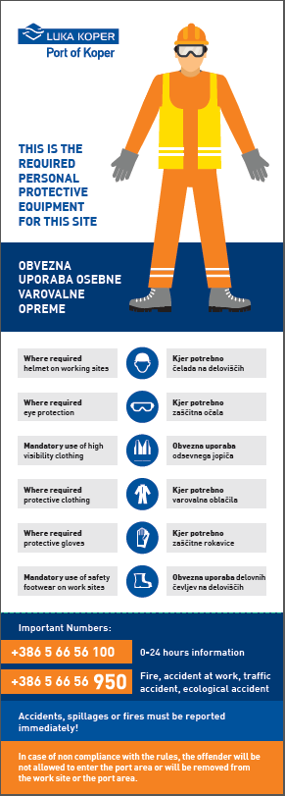  Safety measures  Signature and stamp of the applicant's responsible person:  ---------------------------------------------- | 